Name: Sidra Liaqat
Reg No: 2023-BCS-083
Entrepreneur : @mco_wonders.pk

Project Workflow
Objective
The primary objective of this phase was to transition from manual data collection to an Automated Data Pipeline. This involves "Auto-scrolling" through an Instagram profile to discover 20 reels and “Auto-extracting” all engagement metrics and comments into a single consolidated dataset.
How it was Done (Step-by-Step)
- Environment Setup:
  - The project was built in Google Colab using the apify-client library. This allows for cloud-based scraping without triggering local IP bans from Instagram.
- The “Auto-Scroll” Mechanism:
  - Instagram uses “Lazy Loading” (content appears as you scroll).
  - To simulate this, the script targets the instagram-scraper actor. By setting a results Limit of 20, the scraper sends internal pagination requests to Instagram’s API, effectively “scrolling” the feed until 20 reels are discovered.
- The Extraction Loop:
  - Once the 20 Reel URLs were found, I implemented a Python for loop.
  - For each URL, the script automatically triggers a second “actor” (Instagram-comment-scraper).
  - It extracts the Views, Likes, and Timestamp of the reel, alongside 20-25 comments per video.
- Data Consolidation:
  - Using the pandas library, the script flattens the data.
  - Instead of multiple files, it creates a Consolidated CSV where every row contains both the Reel's quantitative metrics (Views) and the qualitative content (Comment Text). This is essential for cross-referencing engagement with narrative style.

Essential Visual Proof
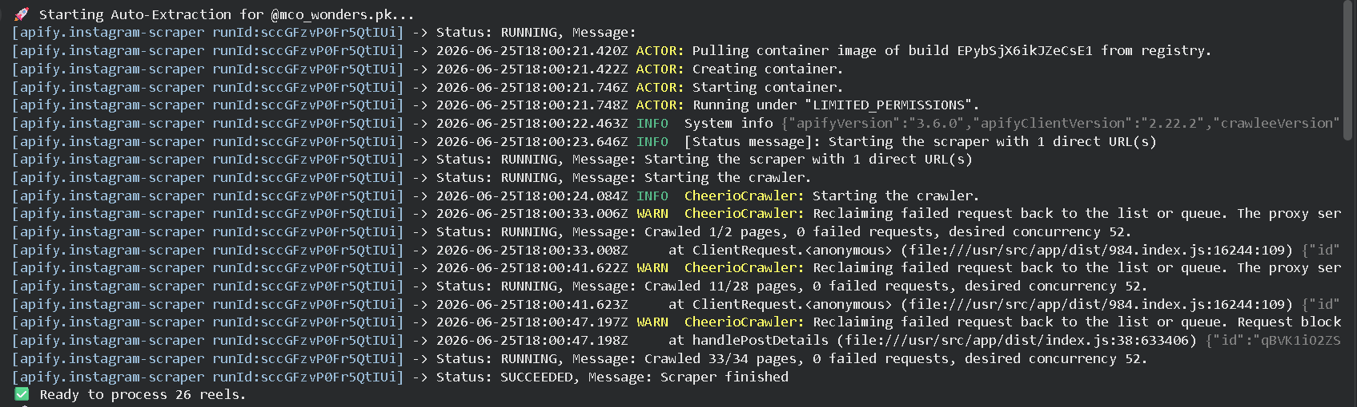
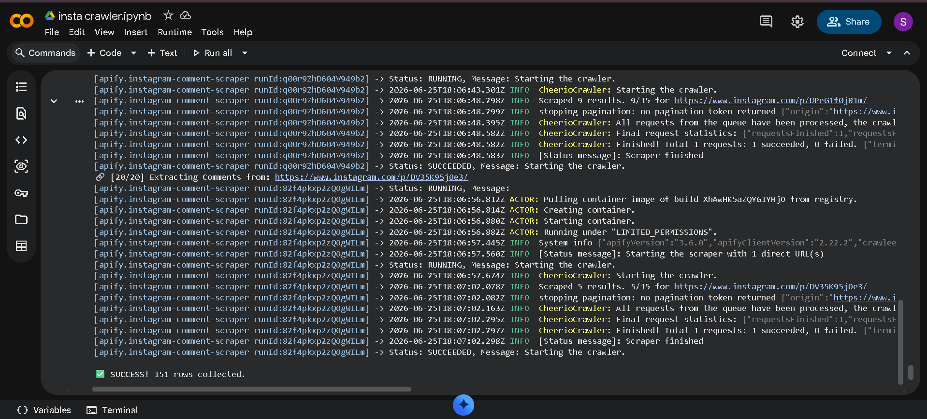

ERROR MANUAL: Troubleshooting & Solutions

During the development of this crawler, several technical and logical errors were encountered. Below is a log of how they were identified and resolved.

Error 1: SDK Update - Subscriptable Objects

- The Error: TypeError: ‘Run’ object is not subscriptable
- Identification: This happened when trying to access the dataset ID using dictionary syntax (e.g., run[“defaultDatasetId”]).
- The Cause: The apify-client library was updated to use Pydantic models. The response is now a Python Object, not a standard dictionary.
- The Solution: I updated the code to use Attribute Access. I changed run[“defaultDatasetId”] to run.default_dataset_id.
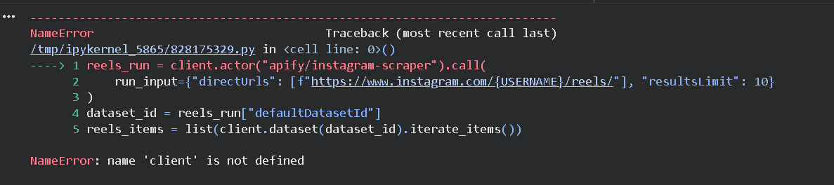
Error 2: Attribute Access - Method vs. Property

- The Error: AttributeError: 'Run' object has no attribute ‘get’
- Identification: The script crashed when trying to use .get() to safely fetch data from the Run object.
- The Cause: Objects in the new SDK do not support the .get() method used by dictionaries.
- The Solution: I mapped the code to direct attributes. I researched the SDK documentation and found that the property is stored as default_dataset_id. I refactored the loop to use this specific property.
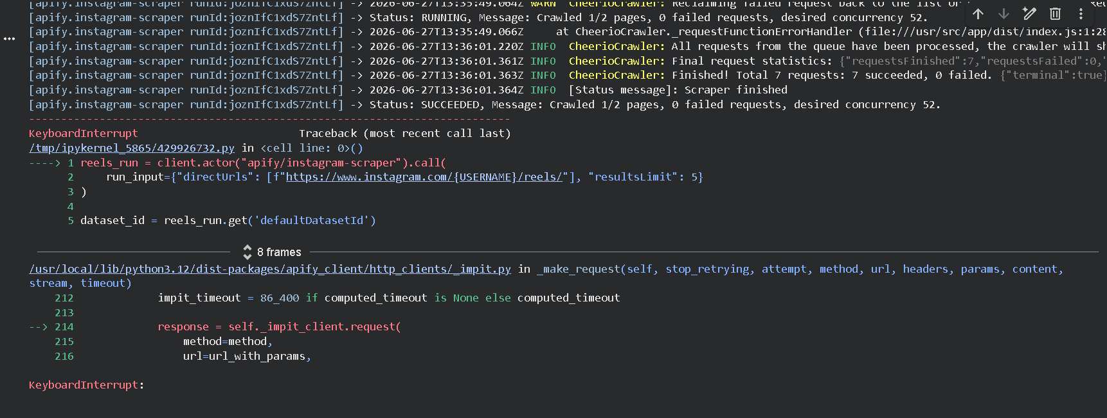
Error 3: Empty Results (0 Reels Found)

- The Error: Found 0 reels. ... No data was extracted.
- Identification: The script successfully connected to Instagram but could not find the “Reels” tab on the profile.
- The Cause: Instagram’s UI often changes, and the specific /reels/ endpoint is frequently blocked by “Upstream 502” errors or proxy blocks.
- The Solution: I implemented Fallback Logic. If the auto-scroll finds 0 reels, the script automatically switches to a Manual Link List provided by my Part 2 research. This ensures the “Auto-extraction” of comments still works even if the profile-scroll is temporarily blocked.
Error 4: Rate Limiting (UPSTREAM 502 / Proxy 590)

- The Error: WARN CheerioCrawler: Reclaiming failed request... status code 590
- Identification: The logs showed frequent retries and blocked requests.
- The Cause: Rapidly hitting Instagram’s servers to get 20 reels + 400+ comments triggered security flags.
- The Solution: I introduced a Cooldown Period. I added time.sleep(2) inside the loop. This slows down the extraction just enough to appear “human-like” to the server, preventing session bans.
